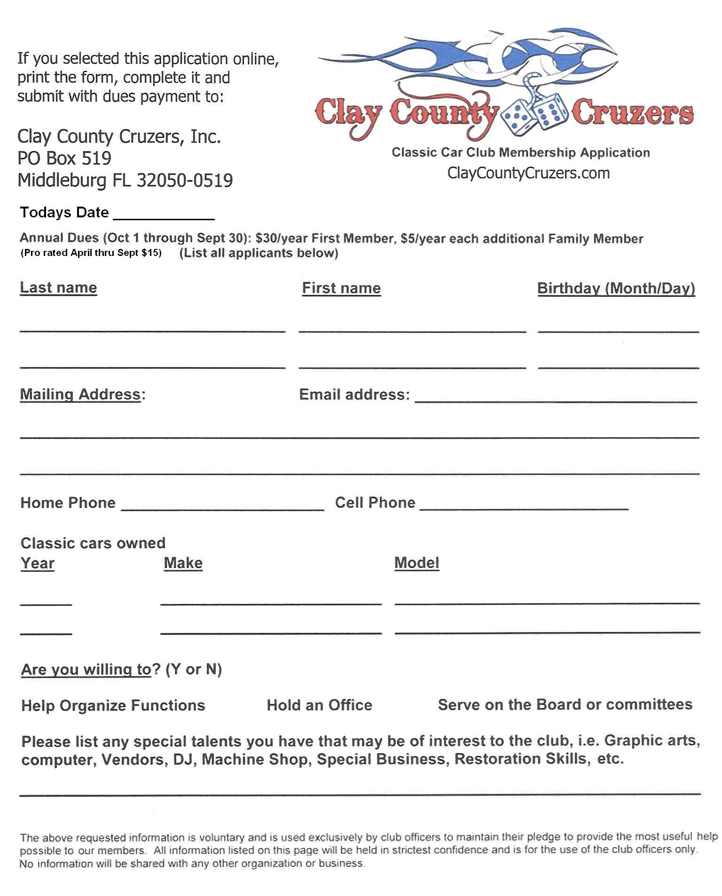

Clay County Cruzers

PO Box 65010

Orange Park, FL 32065-9998